Project Initialization and Planning Phase

Date | 28 January2026
Team ID | LTVIP2026TMIDS66979
Project Name | Explore With Ai: Custom Itineraries For Your Next Journey
Maximum Marks | 3 Marks

Define Problem Statements (Customer Problem Statement Template):

Travel planning and content creation often take a lot of time and effort because they require continuous research and personalization. Many individual travellers find it difficult to create customized travel itineraries that match their interests and trip duration, which can be confusing and frustrating. In the same way, travel agencies struggle to quickly prepare personalized itineraries for multiple clients due to repetitive manual work. Travel websites and content creators also face challenges in regularly producing engaging and updated travel content. These difficulties create a need for an intelligent and automated solution. The Explore with AI system addresses these challenges by using generative AI to automatically generate personalized travel itineraries and relevant travel content with minimal manual effort.
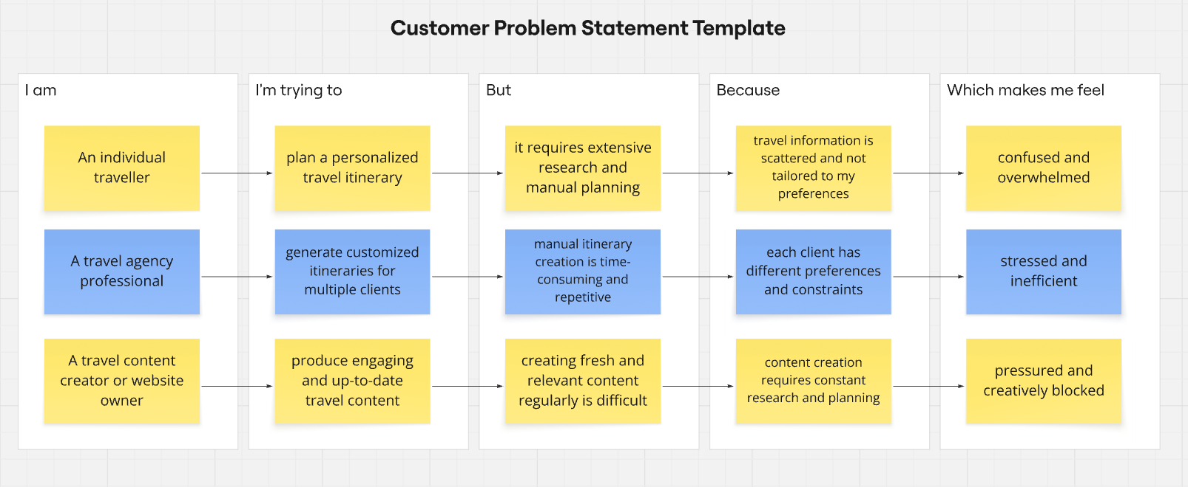
Reference: https://miro.com/templates/customer-problem-statement/

Problem Statement (PS) | I am (Customer) | I’m trying to | But | Because | Which makes me feel
PS-1 | An individual traveller | plan a personalized travel itinerary | it requires extensive research and manual planning | travel information is scattered and not tailored to my preferences | confused and overwhelmed
PS-2 | A travel agency professional | generate customized itineraries for multiple clients | manual itinerary creation is time-consuming and repetitive | each client has different preferences and constraints | stressed and inefficient
PS-3 | A travel content creator or website owner | produce engaging and up-to-date travel content | creating fresh and relevant content regularly is difficult | content creation requires constant research and planning | pressured and creatively blocked

